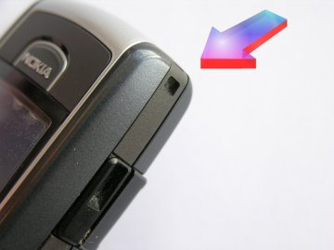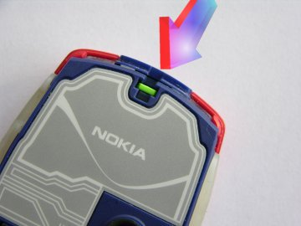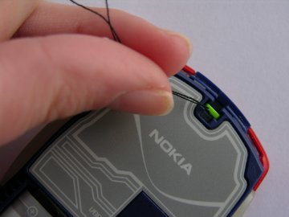
Most mobile phones now have a small lanyard mounting loop built into the plastic casing , an example of this is shown here.

When your phone has this type of mounting , simply pass the charm thread through the case and loop the charm back through itself and pull tight carefully.
Some older phones have internal mounting loops , on this type of phone you will need to remove the back of the phone cover as indicated in the manufacturers handbook and carefully attach the thread and close the case again . Please refer to the photograph to see a typical example.
It requires a little patience to thread the charm string through the internal mounting loop , you might find it easier to use a thin piece of cotton looped around the charm string , which can then be carefully pushed through the loop and gripped with a pair of tweezers.
When the charm string is through the plastic mounting loop , pass the charm back through itself and carefully align the string with the cutout in the case. Close the case on the phone as instructed by the phone manufacturer.

